STORAGE ACCOUNTS AND CONTAINERS

[Jobaoushadancse2021@jerusalemengg.ac.in](mailto:Jobaoushadancse2021@jerusalemengg.ac.in)

Job Aoushadan N – 07.08.2025

1. Create a storage account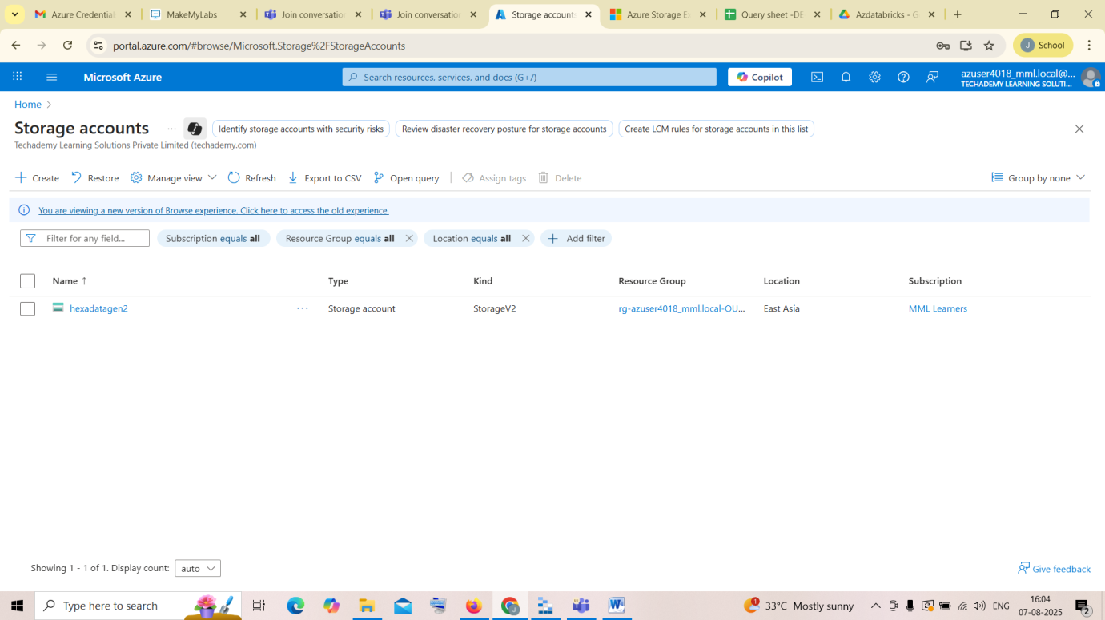

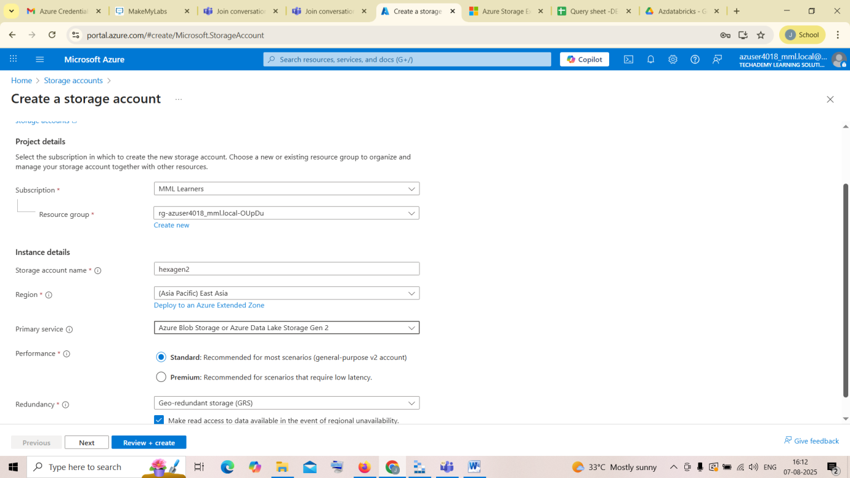

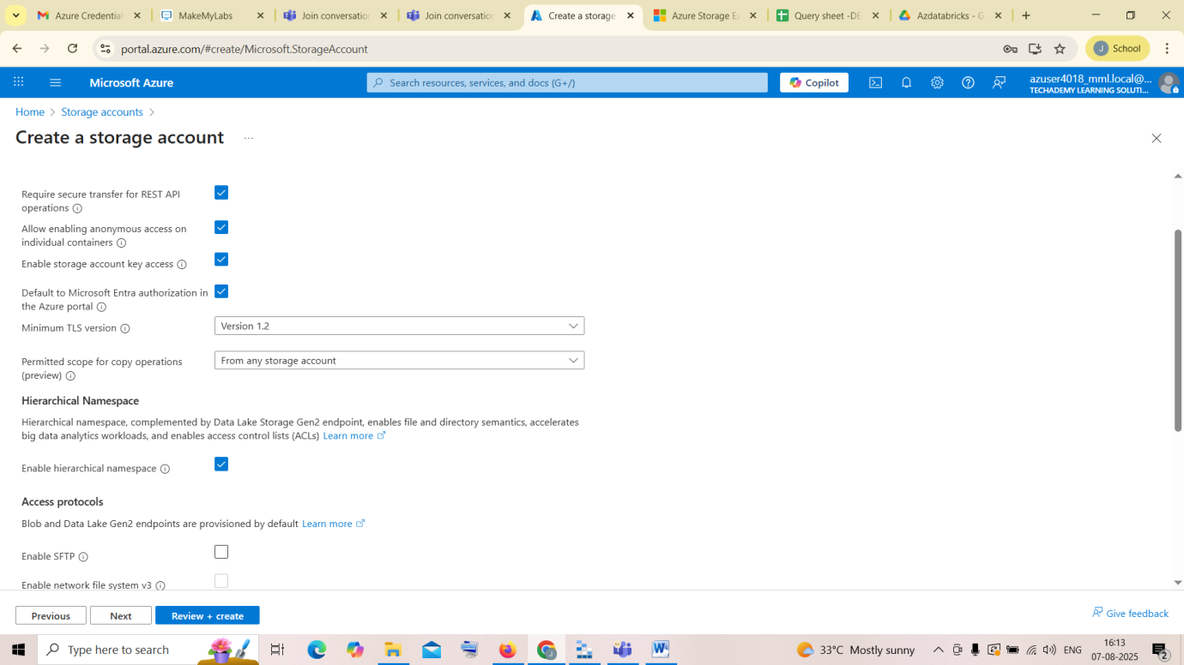

And the review and create it

1. Create a container, open it and switch it to access key

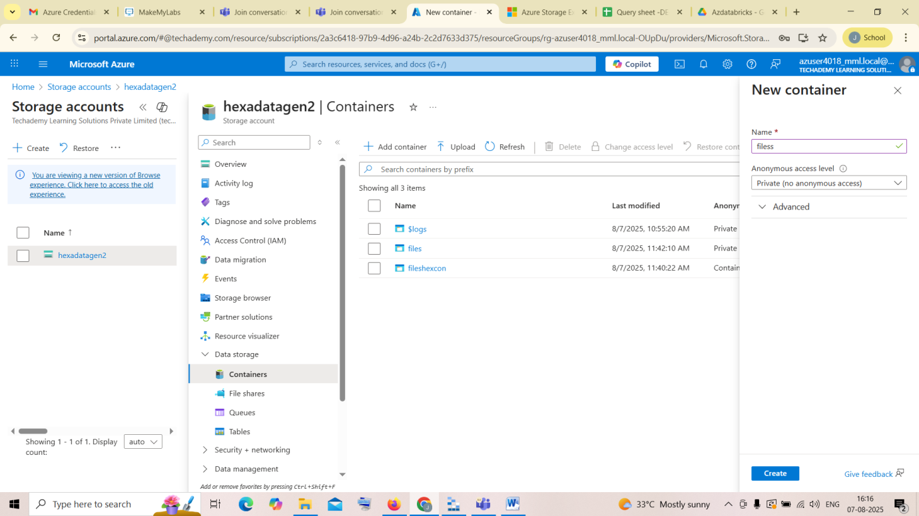

1. Download Microsoft Azure Storage Explorer

<https://azure.microsoft.com/en-in/products/storage/storage-explorer/>

and open it sign in to your Azure account

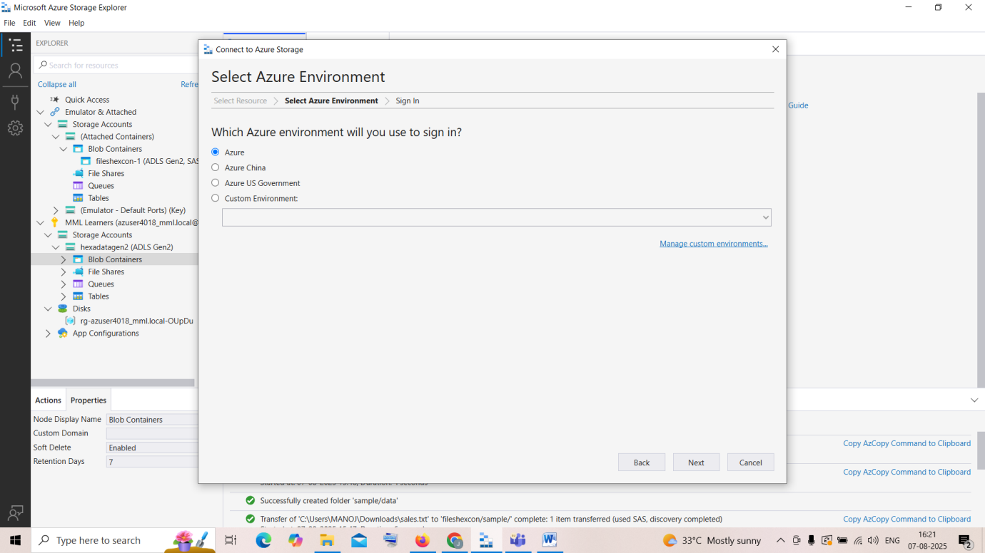

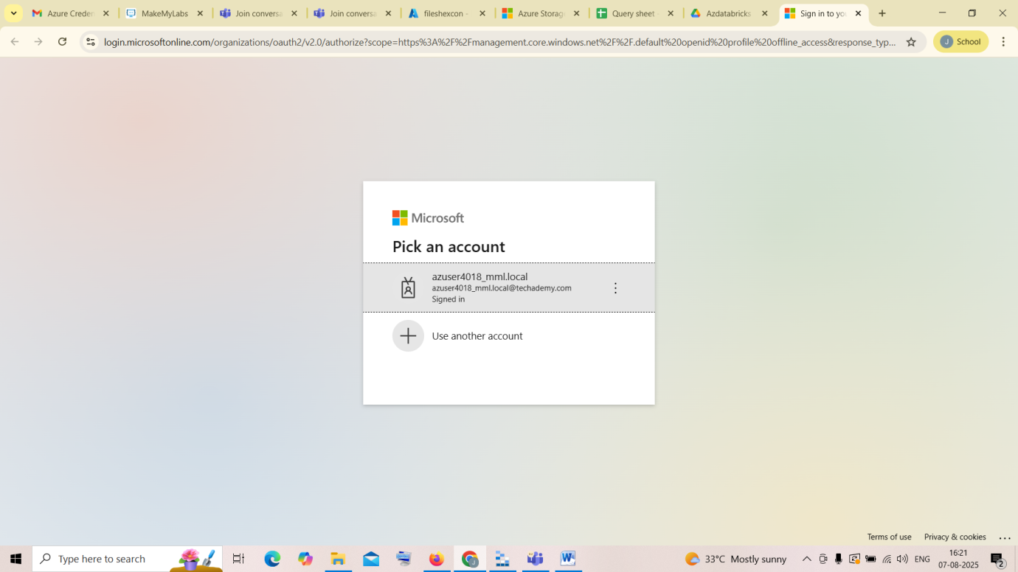

1. click connect to Azure resources and click blob container or directory

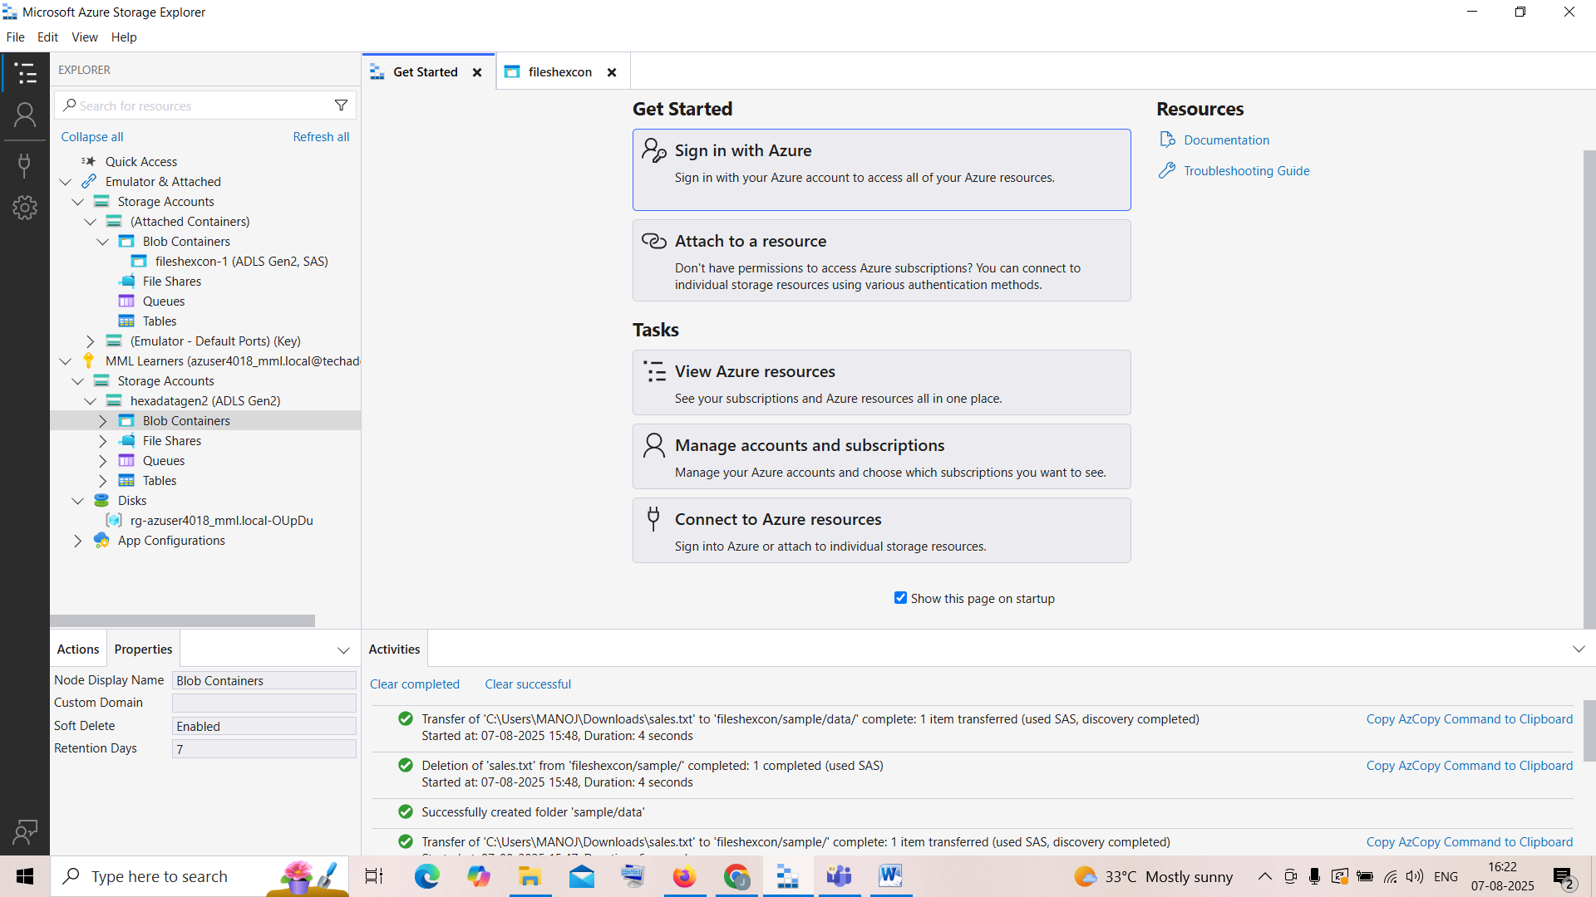

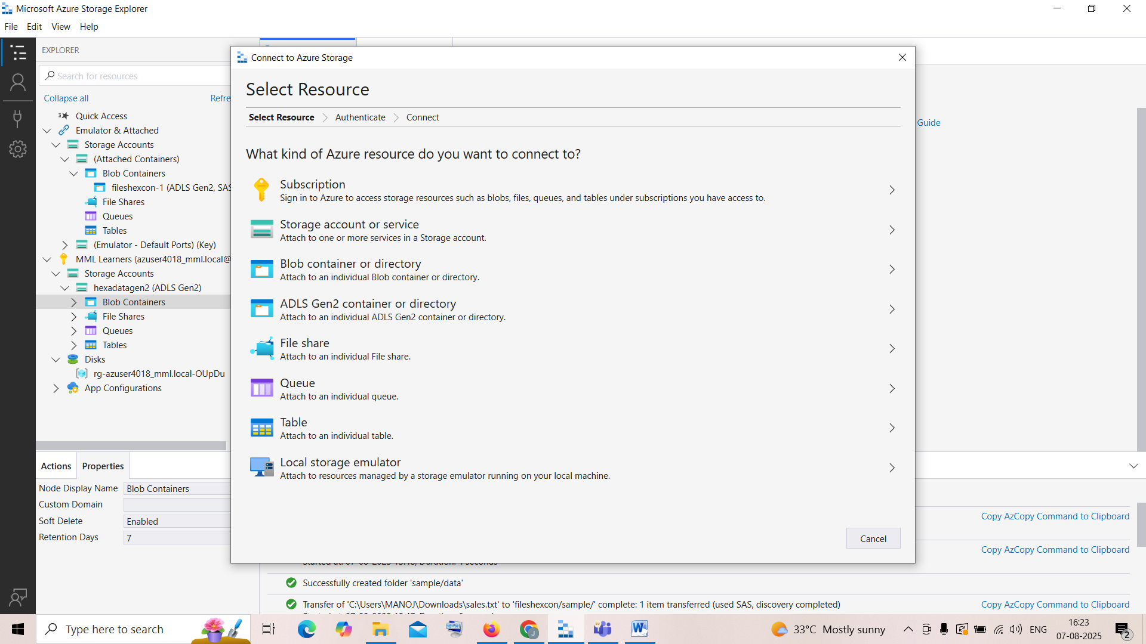

1. Go to the created container on Microsoft Azure , and open shares access token

Give required actions like Read,Create,Write,Delete,List

And Generate URL

List is important to connect the data to storage explorer

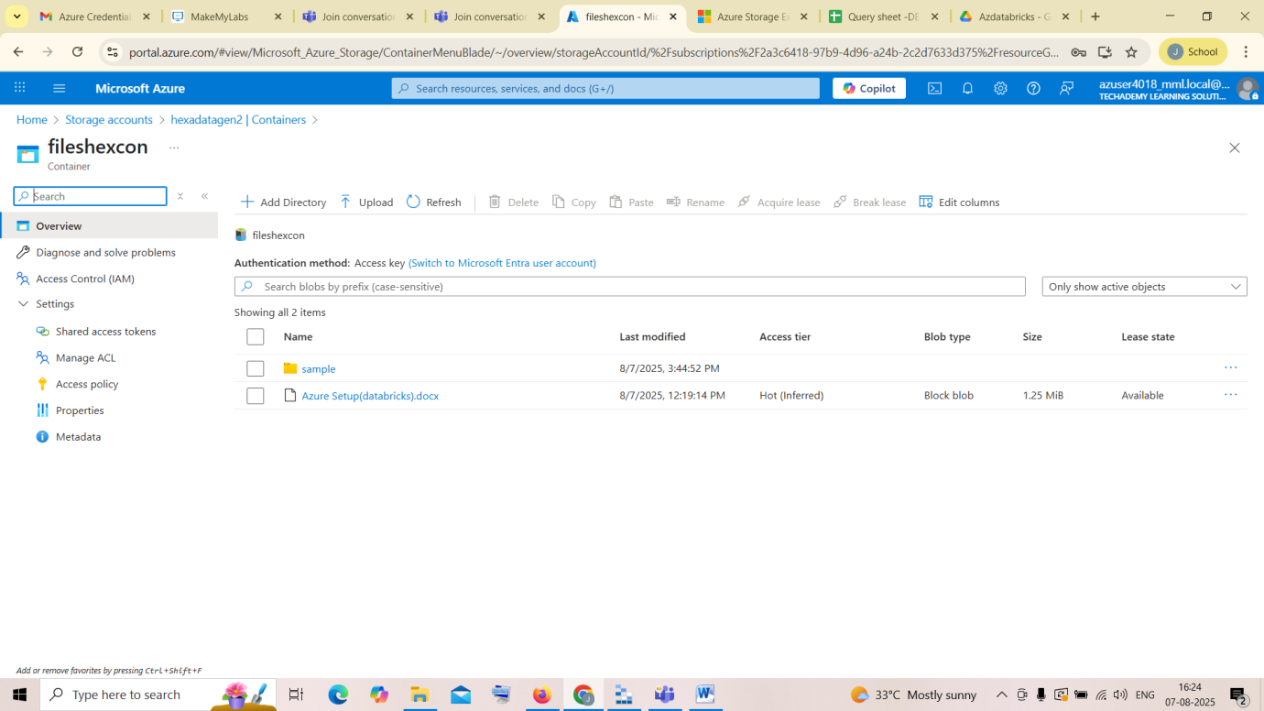

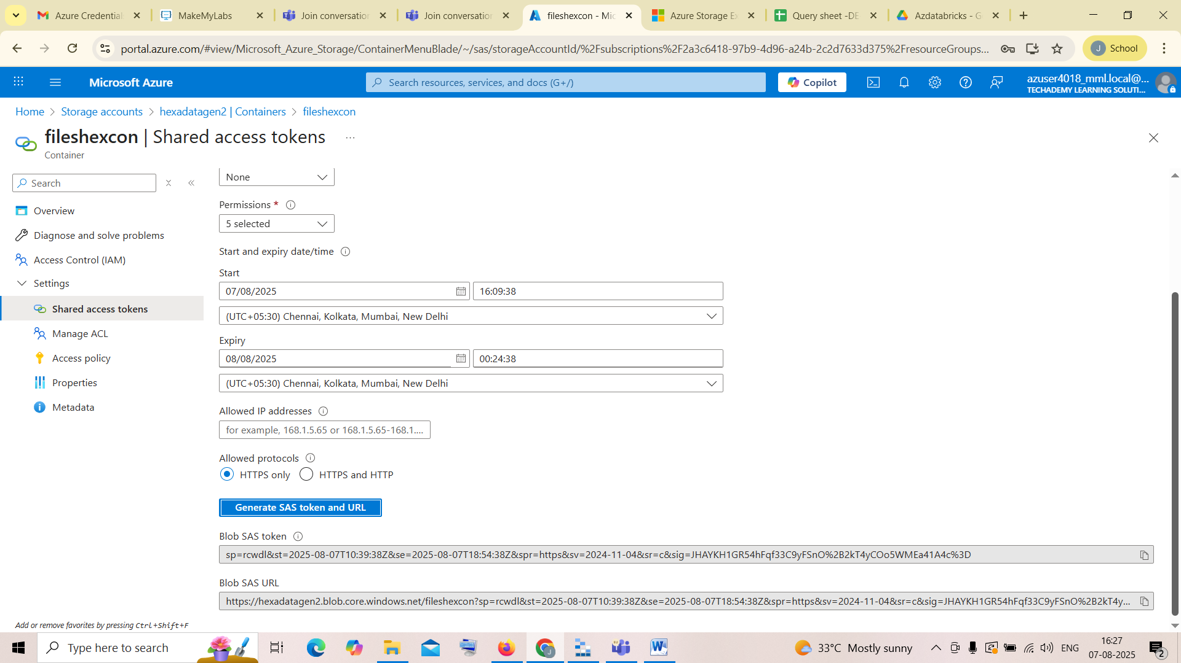

1. Open storage explorer, inside click on connect to Azure resources and click blob container or directory, there you’ll find Shared access Signature (SAS) click on it and paste the generated SAS URL and click next and connect it

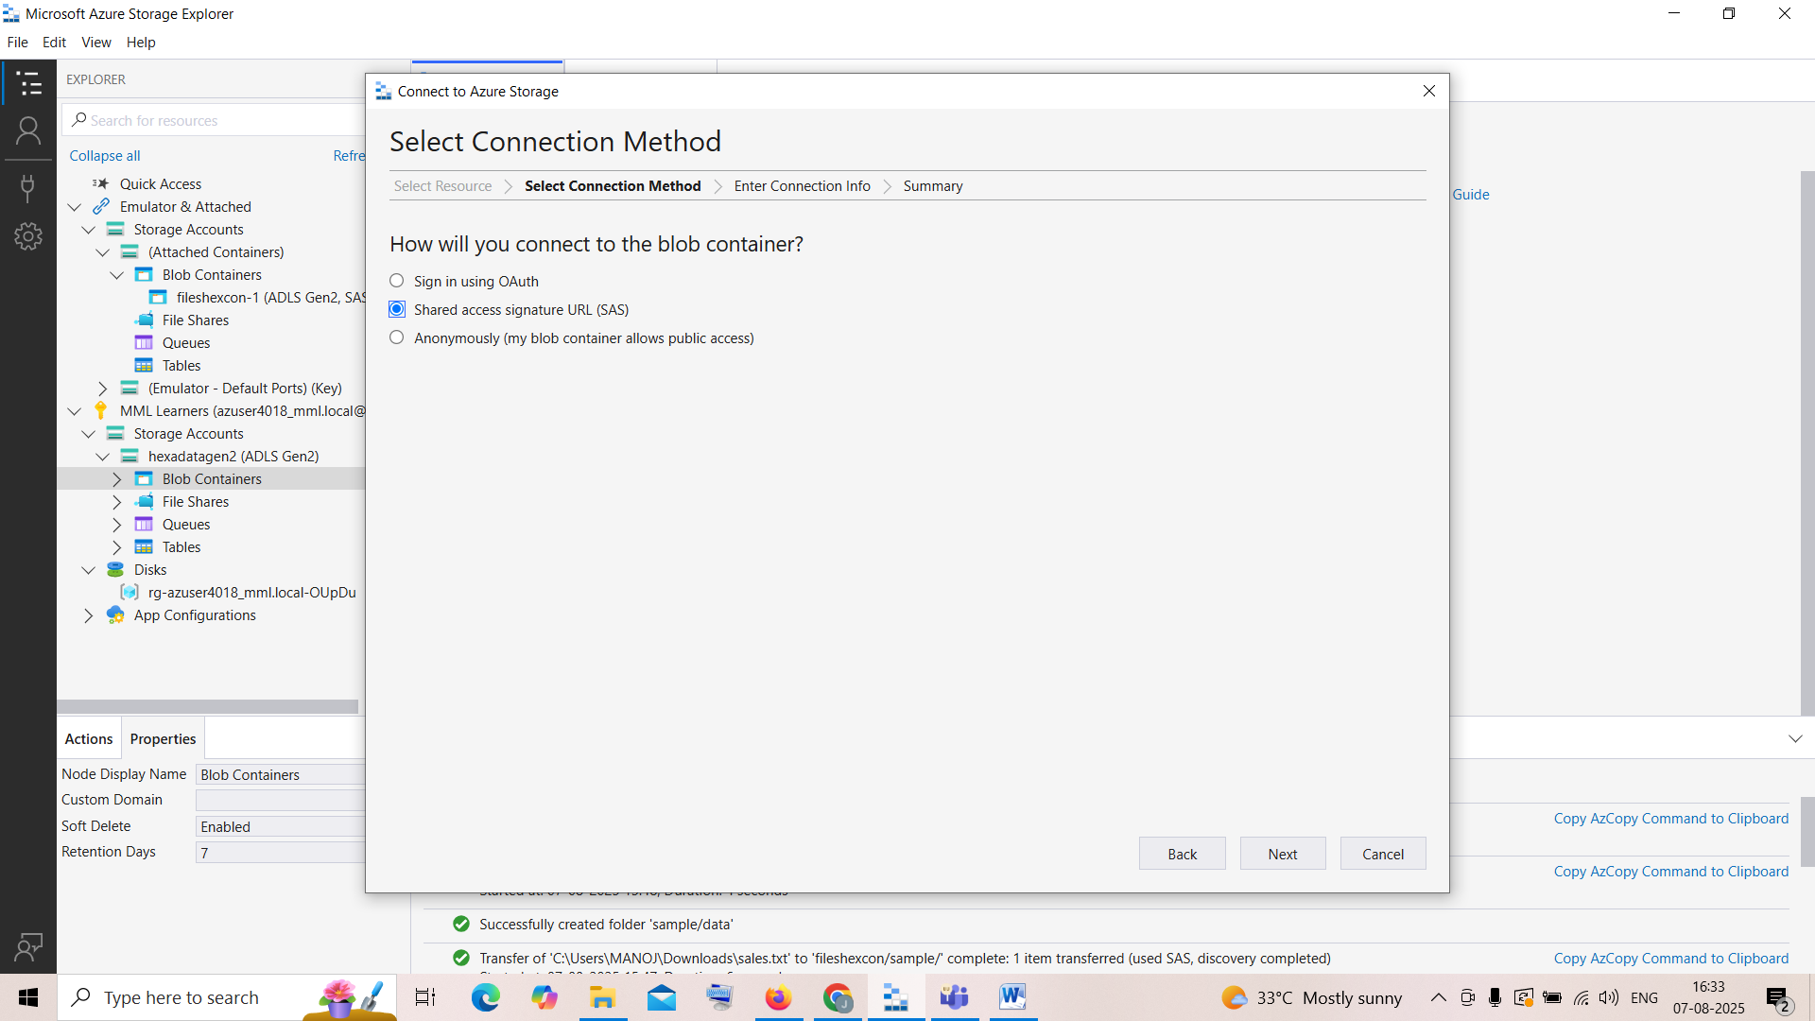

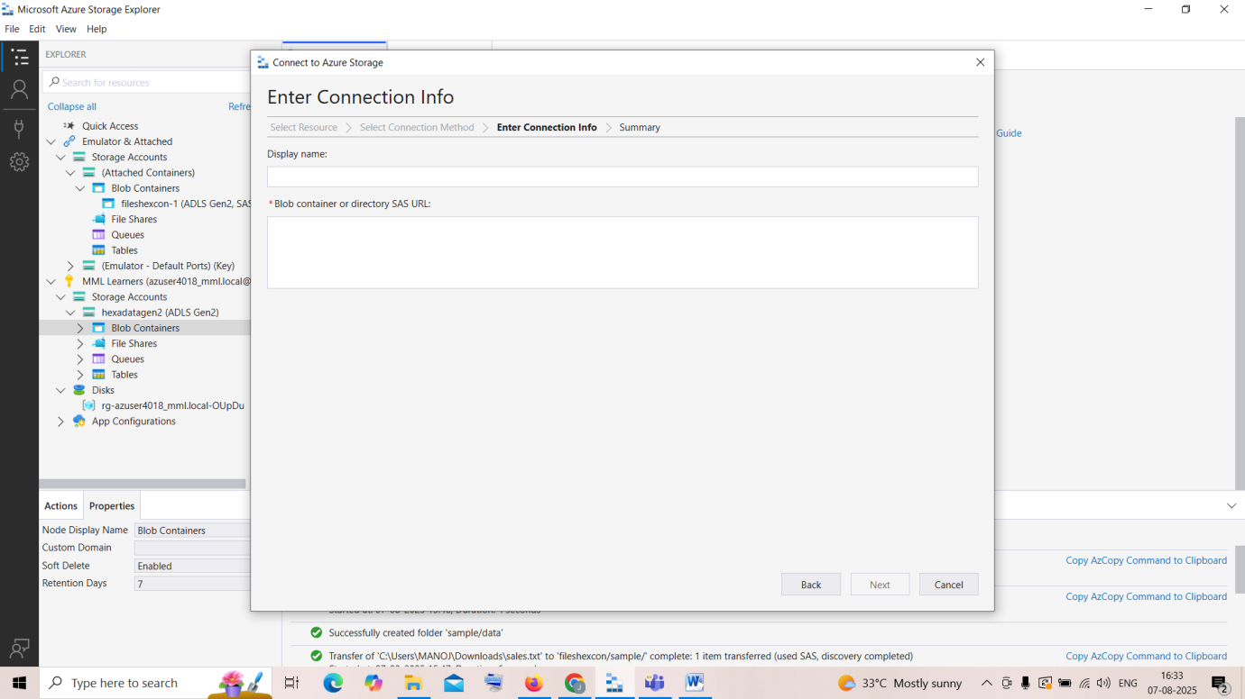

1. After connecting you can see all the files inside your folder

You can create a new folder named sample , inside that create a folder named data and inside that upload a .txt file

The user can access the data under this container for a specific period of time

Until the Expiry date

